1. **INTRODUCTION**
2. **Introduction of the System**

The Project ***Student Result Processing System*** Software is a complete multi-user Web-Application. The admin accepts and then processes the scores of students and subsequently produces their report cards and other analysis charts.

This project aimed at providing a school to analyze the student performance by generating reports like Merit list, Progress reports as key features to reduce manual analysis.

1. **Project Title**

"CANARA EXAM MANAGER”

*Student Result Processing System*

1. **Category**

Web Application

1. **Overview**

An individual report card of each student has to be displayed and printed at a keystroke according to any selected format. An important aid for students to judge their performance. Merit list printing by totals for a class by individual subject marks for a class. Student performance in a particular exam or all the exams must be expressed.

1. **Background**
2. Introduction of the Company
3. Brief note on Existing System

In the manual student result processing system, all the database commands have to be typed by the users. This procedure is very time consuming, and is limited to a single system. If someone want to get information about a particular subject score, student’s performance or any other content related to college, they have to contact the administrator handling the system.

In the proposed system, there are various controls to provide user friendliness. Details can be accessed over the internet, and huge amount of data, records and information can be stored. It provides high level of security, and there is no risk of data mismanagement. The overall result processing system is easier to use, flexible and with more features.

1. Objectives of the System

* The main objective of the system is to provide examination result to the student in a simple and user-friendly way.
* The privileges that are provided to student are to read his/her result and to compare and view his/her performance using graphical charts by providing user id and password for secure login and in case of new student the registration is done by the administrator (office) and the user id and password will be provided by the administrator.
* The privileges that are provided to staff are to read students results and to provide remarks on his/her performance by providing user id and password for secure login and in case of new staff the registration is done by the administrator (office) and the user id and password will be provided by the administrator.
* The privileges that are provided to administrator are to view and update the details of students and staff by providing the admin id and password for secure login.

1. Scope of the System

In “Student Result Processing System” there are various controls to provide user friendliness. Details can be accessed over the internet, and huge amount of data, records and information can be stored. It provides high level of security and there is no risk of data mismanagement. The overall result processing system is easier to use, flexible and with more features.

1. Structure of the System

* Home Page
  + - About
    - Contact
    - Student Login
    - Staff Login
* Login
* Admin Page
  + - Home
    - Log Out
    - Dashboard
* Staff Page
  + - Home
    - Log Out
    - Dashboard
    - Results
    - Performance
* Student Page
  + - Home
    - Log Out
    - Dashboard
    - Results
    - Performance

Modules

Administrator

Dashboard: Administrator has a dashboard where he/she can manage all the functionality at one place.

Add or Remove User: He/she can add or remove any user or users i: e staff or students.

View Student Details: He/she can view the details of staff and students.

Update Student Details: He/she can update the details of students.

View Staff Details: He/she can view the details of staff.

Update Staff Details: He/she can update the details of staff.

Update Examination Result Details: He/she can update the details of examination results.

View Courses and Subjects: He/she can view the courses and subjects offered in the university.

Update Courses and Subjects: He/she can add or remove any courses and subjects and also modify them.

Staff

Login: Staff is provided with separate login page where he/she has to enter username and password that is provided to them by the Administrator. This module is for user authentication.

Dashboard: Staff has a dashboard where he/she can manage all the functionality at one place.

View Student Details: The staff can view the details of each student.

Check Examination Result: He/she can check the examination results of the students.

Check Student Performance: He/she can analyze the performance of each student through graphical charts.

Give Remarks: He/she can give remarks to students performance which can be viewed by the students.

Student

Login: Students are provided with separate login page where he/she has to enter username and password that is provided to them by the Administrator. This module is for user authentication.

Dashboard: Student has a dashboard where he/she can manage all the functionality at one place.

View Personal Details: He/she can view their personal details.

Check Examination Result: He/she can check their examination results including the remarks provided by the staff.

Check Performance: He/she can analyze their performance through graphical charts.

1. System Architecture

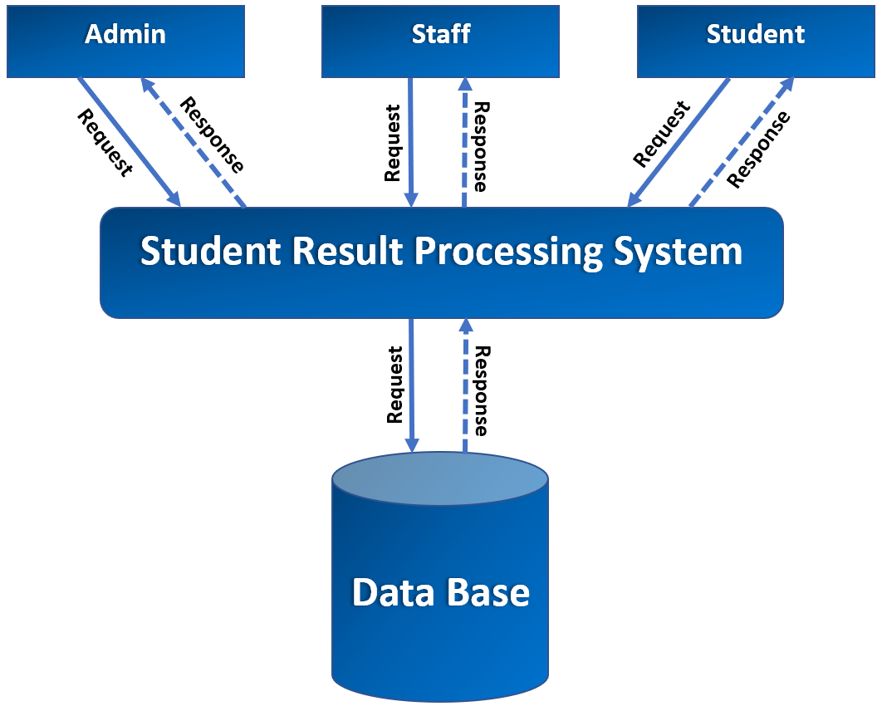

1. End Users

Administrator Role: Manipulates all the records. Provides authorization to the users (students/staff). An admin can add or remove users (students/staff). He/she can view and update the personal details of the students and staff. He/she can view and update the examination results of students.

Staff Role: Provides remarks to the student’s performance. He/she can view their own personal details and the personal details of student’s. He/she can view the examination results and analyze the performance of students through graphical charts.

Student Role: Can view their examination results. He/she can analyze their performance through graphical charts.

1. Software/Hardware used for development

Software:

|  |  |
| --- | --- |
| **IDE / Text Editor** | Brackets, Visual Studio Code, Eclipse. |
| **Web Contents** | Java Servlets, JSP, HTML, CSS, Java Script. |
| **Server-Side Programming** | Java |
| **Database** | My SQL |
| **Documentation Tool** | MS Office |

Hardware:

|  |  |
| --- | --- |
| **Processor** | i3 2.30 GHz |
| **RAM** | 8GB RAM |
| **Memory** |  |
| **Graphics Card** | 4GB Intel® UHD Graphics 620 |

1. Software/Hardware required for the implementation
2. **SOFTWARE REQUIREMENTS SPECIFICATION**
3. **Introduction**

The introduction of the Software Requirements Specification (SRS) provides an overview of the entire SRS with purpose, scope, definitions acronyms, abbreviations and overview of the SRS. The aim of this document is to gather and analyze and give an in-depth insight of the online *Student Result Processing System* by defining the problem statement in detail. The detailed requirements of “CANARA EXAM MANAGER” system is provided in document.

* 1. **Purpose**

This document mainly focuses on providing the information about the software requirements of the “CANARA EXAM MANAGER” system, which can be referred by the developers and will be basis for the validation of the final system. The project mainly focuses on exam management, where we can perform activities starting from registration of the students to generation of examination result and analyzing the performance of different examinations and comparing them.

* 1. **Scope**

The scope of this document is to provide sufficient details on the functional and non-functional requirements are properly implemented. This project has an enormous scope in the upcoming days when the institutions can make their work of generating examination results automatic rather than manually doing all the calculations, which will save a lot of time.

* 1. **Definition, Acronyms, Abbreviations**

This particular software is defined as automated software for the examination department of Universities/Institutions.

|  |  |
| --- | --- |
| **SRS** | Software Requirements Specification |
| **SRPS** | Student Result Processing System |
| **CEM** | Canara Exam Manager |
| **DFD** | Data Flow Diagram |
| **ERD** | Entity Relationship Diagram |
| **CFD** | Context Flow Diagram |
| **DBMS** | Database Management System |
| **RDBMS** | Relational Database Management System |
| **GUI** | Graphical User Interface |
| **ADMIN** | The Administrator |
| **JSP** | Java Server Page |
| **SQL** | Structured Query Language |
| **HTML** | Hyper Text Markup Language |
| **CSS** | Cascading Style Sheets |
| **JS** | Java Script |

* 1. **Overview**

1. **Overall Description**

This examination software mainly focuses on the automation of the examination process, which starts from the registration of students to generation of examination result and analyzing the performance of different examinations and comparing them. Here Admin registers every detail of staff and students. The admin uploads the marks after getting the results of the examination (which includes all the examinations i: e from semester exams to internal exams) of the students and the result will be publish which can be viewed by the students.

* 1. **Product Perspective**

The main objective of this **CEM** is to provide examination result to the student in a simple and user-friendly way. It is a web-based application with 3 interfaces Admin, staff and students. All the information is stored in the database, which can be retrieved. The website works with desktops, laptops and mobile with the help of the browser application.

* 1. **Product Functions**
* Registering staffs and students.
* Ability to modify and upload data.
* Marks of the entire semester can be published.
* Allow admin to take control of the entire application.
* Details of each student’s profile are viewable by admin and staff.
* Staffs can view each student profile and exam results.
* Staffs can give remarks to each student based on their performance.
* Students can view their profile.
* Students can view their marks.
* Students can analyze their performance using enhanced graphs.
  1. **User Characteristics**

1. **Admin:** Admin is the core user. He/she has a complete access to the web-application. The admin manipulates all the records. Provides authorization to the users (students/staff). An admin can add or remove users (students/staff). He/she can view and update the personal details of the students and staff. He/she can view and update the examination results of students.
2. **Staff:** These are the users who have access to the information regarding the examination results and profile information of each student. He/she can provide remarks to each student and view also analyze their performance through enhanced graphs.
3. **Student:** These are the users who have access to the information regarding the examination results and profile information related to their profile. He/she can view their examination results. He/she can analyze their performance through enhanced graphs.
   1. **General Constraints**

* The system must be capable of doing parallel operations and must not have scalability issues with regard to number of computers, mobiles, tablets and monitors connected at one time.
* There is a small chance of miscalculations in examination results and performance analysis.
* The developed software should run on any platform (Linux, Mac, Windows etc. which supports Java) that contains a web browser.
* The end user (University) needs a hosting space so that it can be accessed from any remote location.
  1. **Assumptions**
* The code should be error-free.
* Roles and tasks are predefined.
* The Administrator is created in the system already.

1. **Special Requirements**
2. **User Interface:** The user interface of the web-application should be compatible with any browser such as Google Chrome, Microsoft Edge, Mozilla Firefox, Brave etc.

There are 3 user interfaces for 3 different users they are follows: -

* Admin
* Staff
* Student

1. **Hardware Interface:**

* Processors: Intel Pentium dual-core or above.
* RAM: 2 GB and above.
* Hard Disk Utilization:
* Input Devices: Mouse, Keyboard.
* Output Devices: Monitor.

1. **Software Interface:**

* Browser: Microsoft Edge, Google Chrome, Mozilla Firefox, Brave.
* Server: Apache Tomcat.
* IDE’s: Eclipse Enterprise Edition, Brackets, Visual Studio Code.
* Web Components: Java Servlets, JSP, HTML, CSS.
* Language: Java
* Scripting Language: Java Script.
* Database: MySQL.

1. **Communication Interface:**

This is a web-based system, and communication is done through internet and internet protocols are used (HTTP Protocols).

1. **Functional Requirements**

Student Result Processing system is a dynamic web-application that is connected to the database. The students (users) can view their results and analyze their performance. There are 3 modules in this web-application they are: -

1. **Login Module:** This module is used for authentication of the users. Admin, staff and students have different login page where the users have to provide username id and password. Only if the username id and password evaluates to true then he/she can access their profile page.
2. **Admin Module:** The Administrator is the core user of the system. This module has the following functionalities.

* The Administrator should Login into the system with unique his/her username and password.
* Admin views staff Personal details.
* Admin updates staff Personal details.
* Admin views student Personal details.
* Admin updates student Personal details.
* Admin views Results of students.
* Admin updates Results of students.
* Admin views Schedules.
* Admin updates Schedules.
* Admin views courses and subjects.
* Admin updates courses and subjects.

1. **Staff Module:** Staffs are the observers, although they do not have the privileges to change any data or information of the students including examination results. This module has the following functionalities.

* The Staff should login into the system with unique his/her username and password.
* Staff views student’s Personal details.
* Staff views his/her own Personal details.
* Staff views Results of students.
* Staff views Schedules.
* Staff provides remarks for students based on his/her performance.

1. **Student Module:** Students are the basic users of this system. He/she don’t have the privileges to modify the data and information regarding his/her own personal details, examination result details, examination schedules any other details. This module has the following functionalities.

* The student should login into the system with unique his/her username and password.
* Student views his/her own Personal details.
* Student views Results.
* Student views Schedules.
* Student views his/her performance in the examination using enhanced graphs.

1. **Design Constraints**
2. **System Attributes**
3. **Compatibility:** This system will be compatible with almost all the web servers.
4. **Flexibility:** The system keeps updating the data according to the changes takes place.
5. **Portability:** The system can be run in any operating system and browser.
6. **Reliability:** This system is designed to have very simple database just to extract the details of every user. It is tested for all the constraints at development stage.
7. **Security:** This system provides with authentication without which no user can pass. So only the legitimate users are allowed to use the application. If the legitimate users share the authentication information, then the system is open to outsiders.
8. **Timelines:** The system carries out all operations with consumptions of very less time.
9. **Other Requirements**
10. **Safety Requirements:** There are several users in CEM software. Access to the various subsystems will be protected by a user log in screen that requires a username id and password. This gives different views and accessible function of user levels through the system. Maintaining backups ensure the system database security. System can be restored in any case of emergency.
11. **Security Requirements:**

* Depending upon the category of user the access rights are decided.
* Admin has the maximum privileges to all subsystems.
* Only authenticated users can access the sytems.

1. **Performance Requirements:** In order to maintain an acceptable speed at maximum numbers of upload allowed from a particular user as any number of users can access to the system anytime. Also, the connections to the server will be based on the attributes of the user like location and server should be working 24X7.